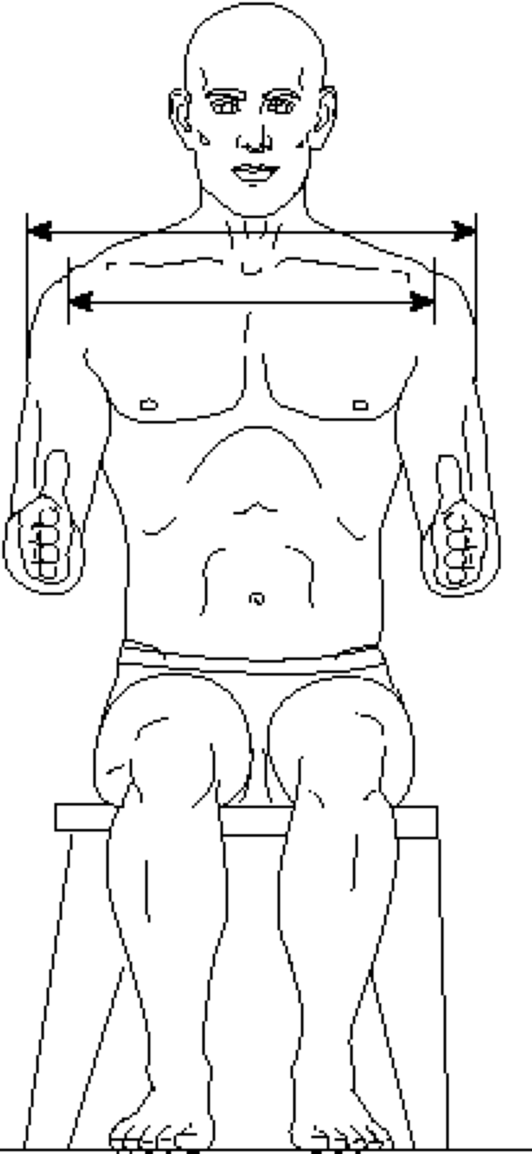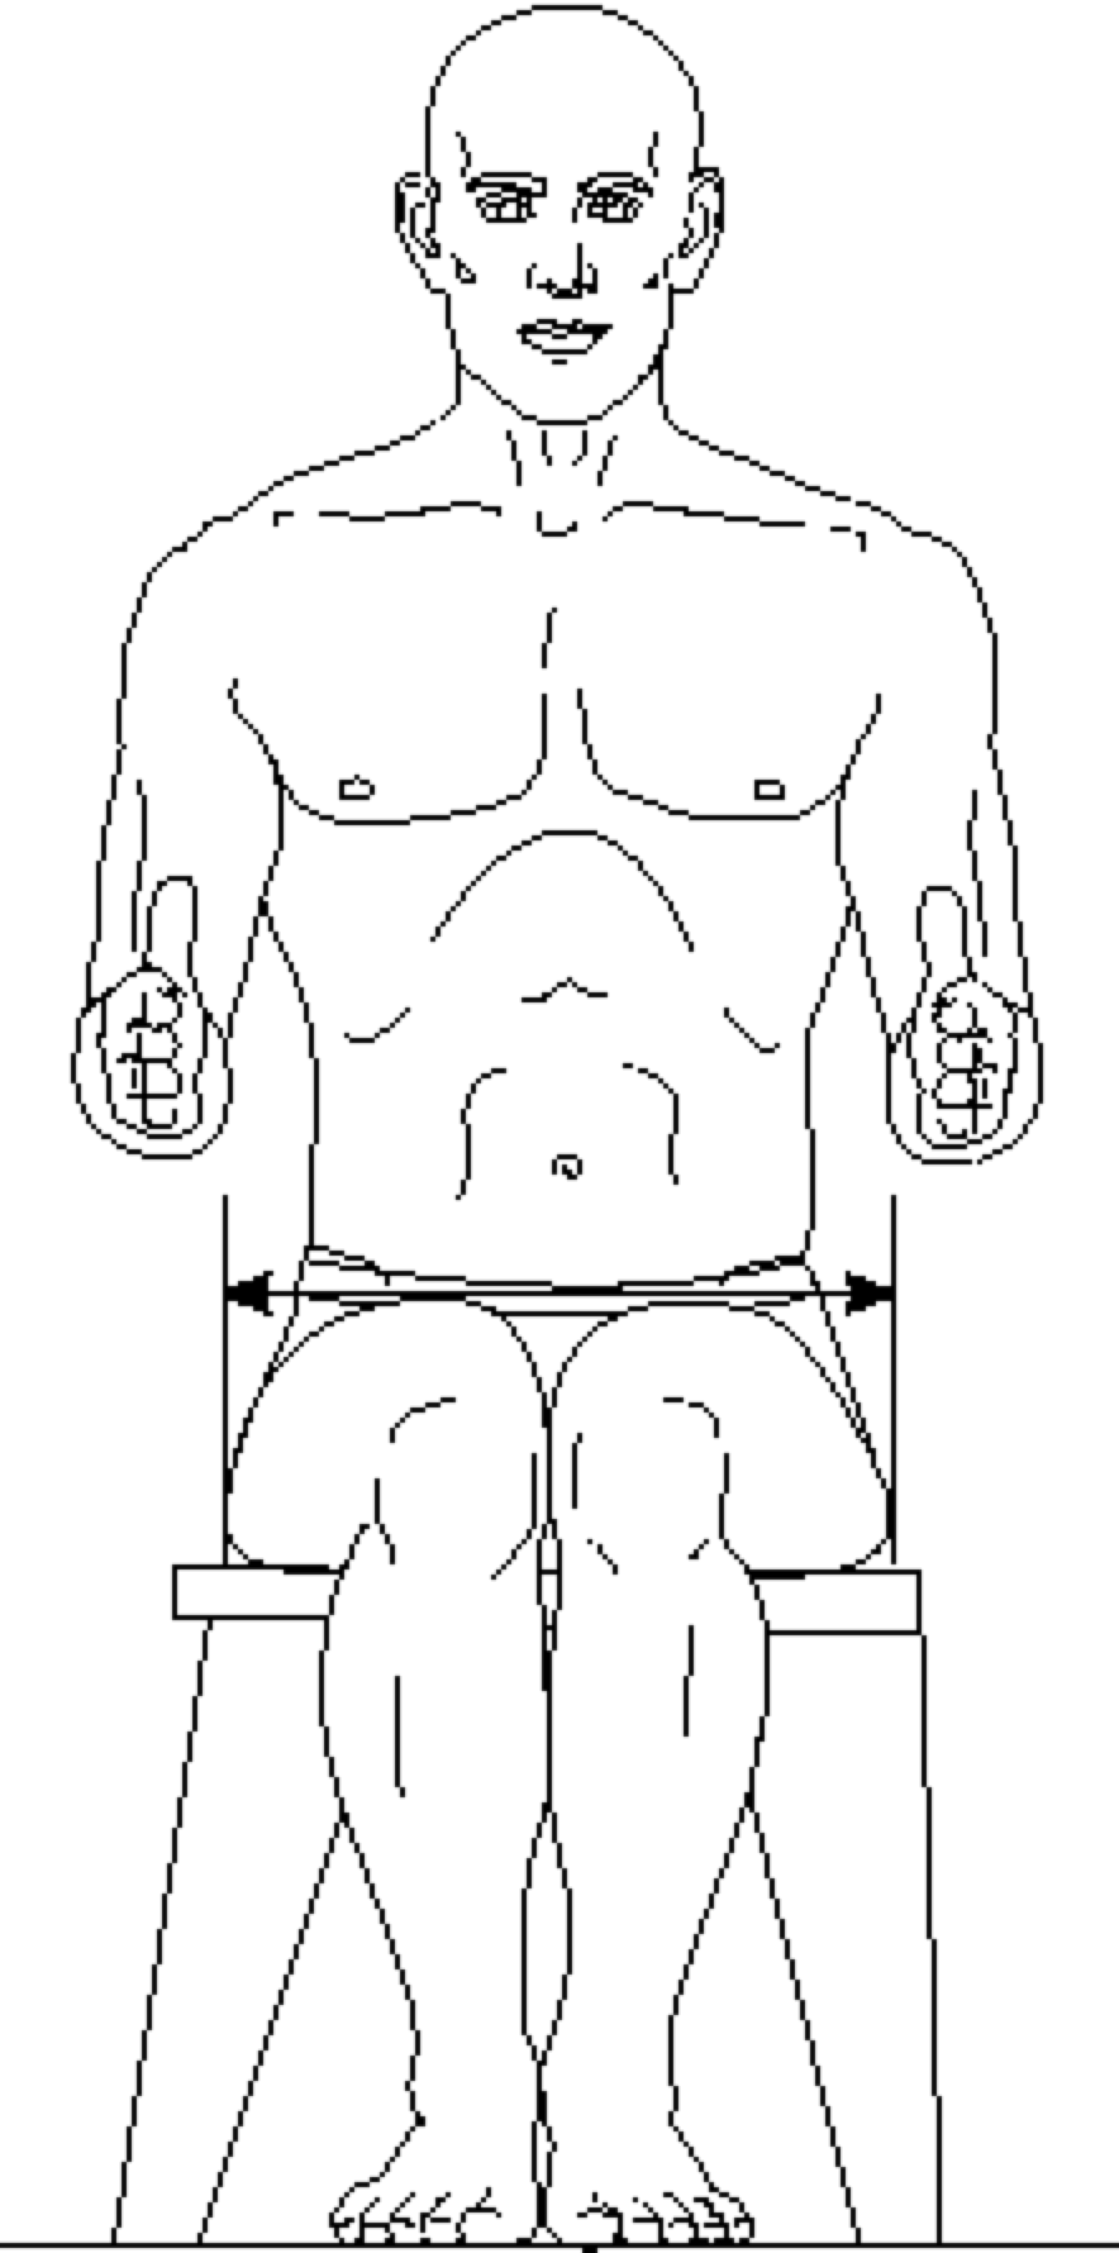

BIDELTOID BREADTH HIP BREADTH, SITTING
BIACROMIAL BREADTH

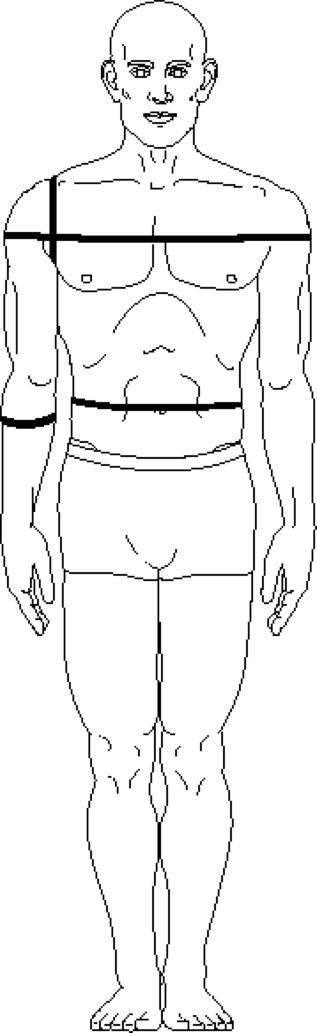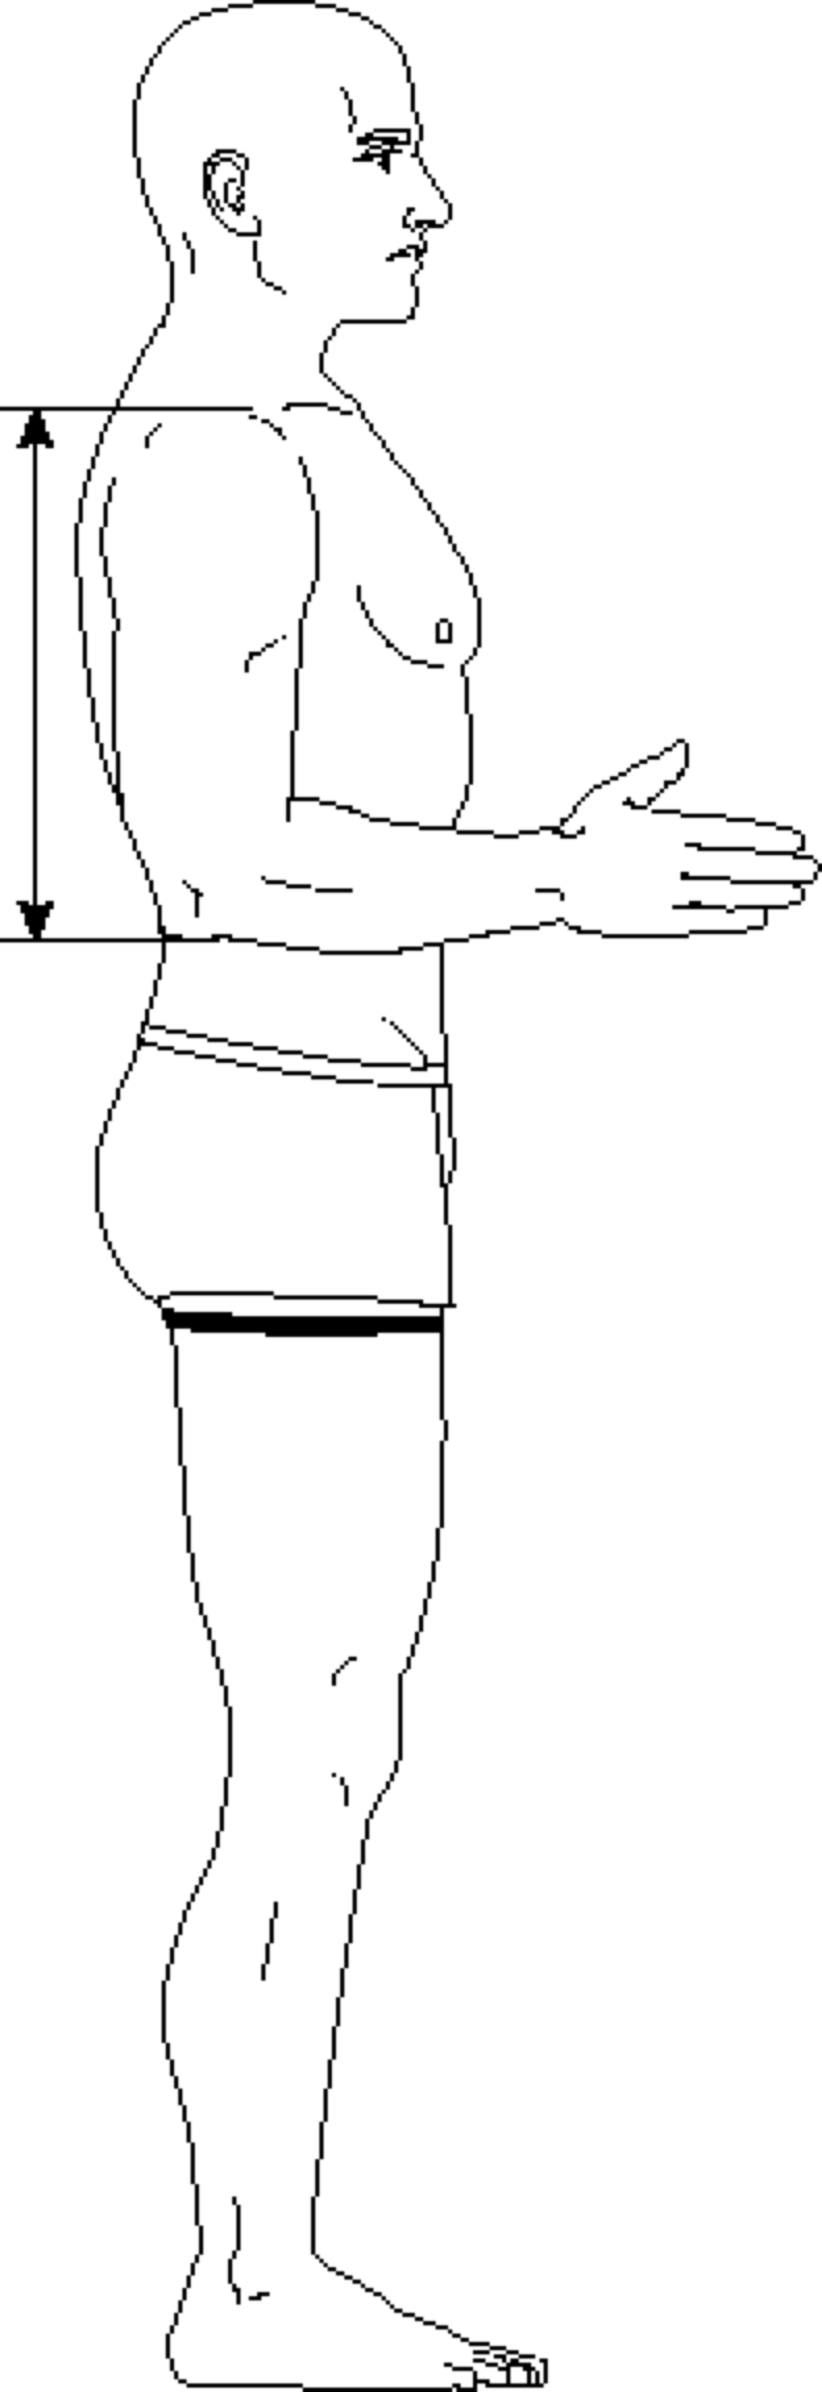

SCYE CIRCUMFERENCE ACROMION-OLECRANON LENGTH
SHOULDER CIRCUMFERENCE THIGH CIRCUMFERENCE, UPPER
FOREARM CIRCUMFERENCE
WAIST CIRCUMFERENCE AT MIDABDOMEN
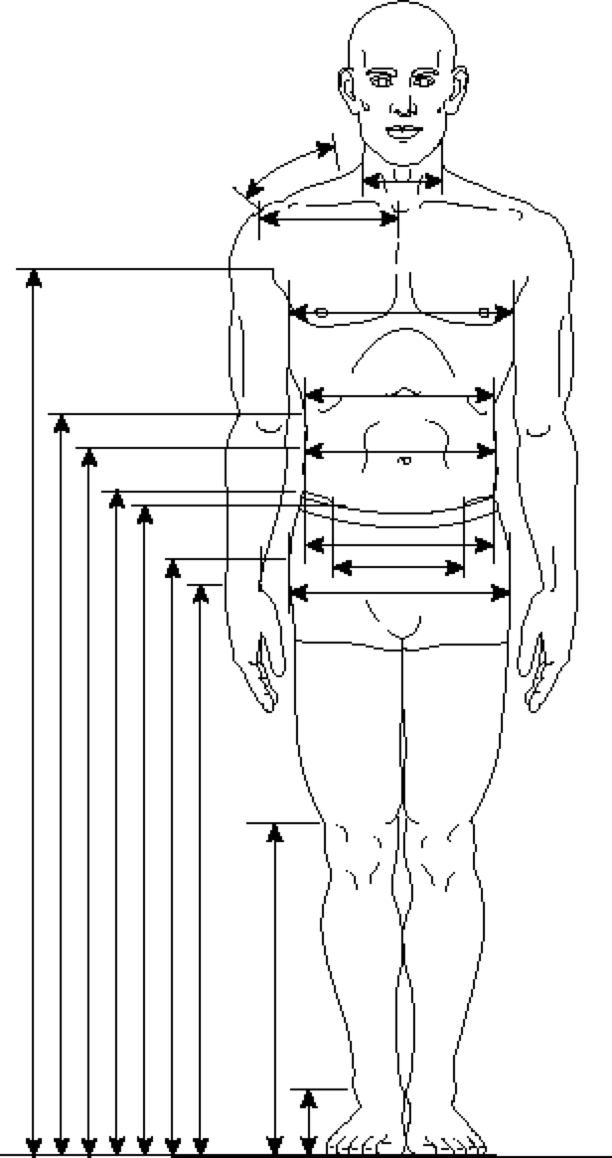

Heights, Outside to Inside:  AXILLA HEIGHT  TENTH RIB HEIGHT  WAIST HEIGHT AT MIDABDOMEN  ILIOCRISTALE HEIGHT  ASIS HEIGHT  TROCHANTERION HEIGHT  WRIST HEIGHT  KNEE HEIGHT AT LATERAL FEMORAL EPICONDYLE  MALLEOLUS HEIGHT, LATERAL | Breadths and Lengths, from Top:  SHOULDER LENGTH  NECK BREADTH  ACROMION-SUPRASTERNALE  CHEST BREADTH AT NIPPLE  CHEST BREADTH AT 10TH RIB  WAIST BREADTH AT MIDABDOMEN  BI-ILIOCRISTALE BREADTH  BISPINOUS BREADTH  BITROCHANTERION BREADTH
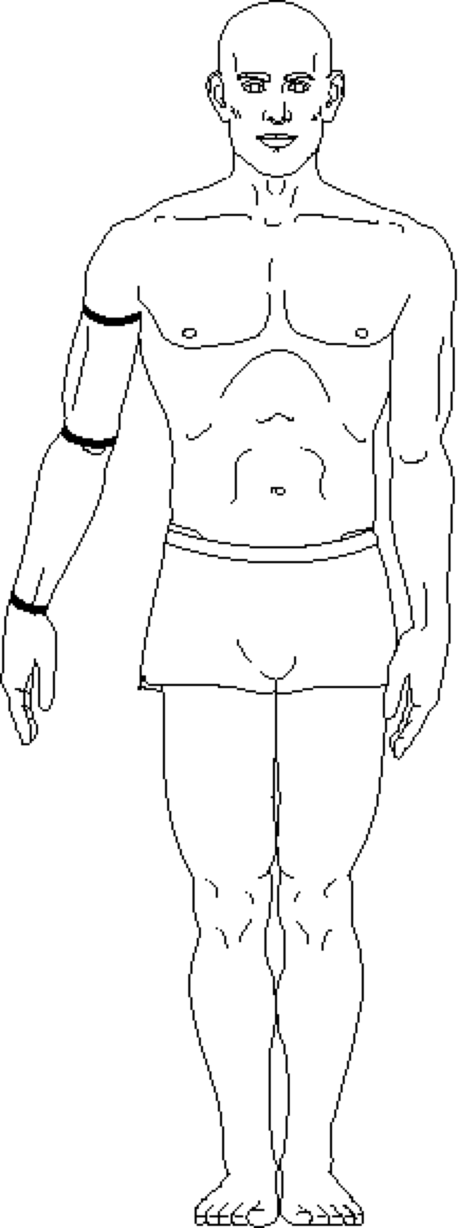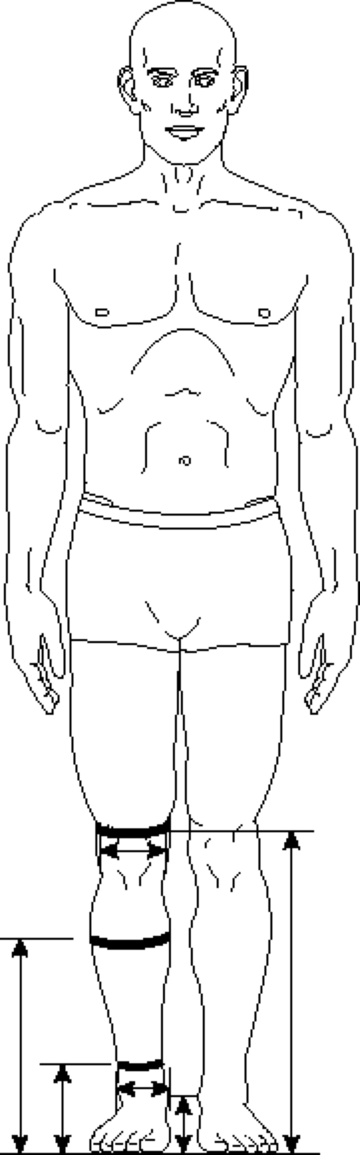

ARM CIRCUMERENCE AT AXILLA  ELBOW CIRCUMFERENCE  WRIST CIRCUMFERENCE | KNEE CIRCUMFERENCE AT LATERAL FEMORAL CONDYLE  FEMORAL BICONDYLAR BREADTH  CALF CIRCUMFERENCE  ANKLE CIRCUMFERENCE, MINIMUM  CALF CIRCUMFERENCE HEIGHT  ANKLE CIRCUMFERENCE HEIGHT  KNEE HEIGHT AT MEDIAL FEMORAL EPICONDYLE  BIMALLEOLAR BREADTH  MALLEOLUS HEIGHT, MEDIAL

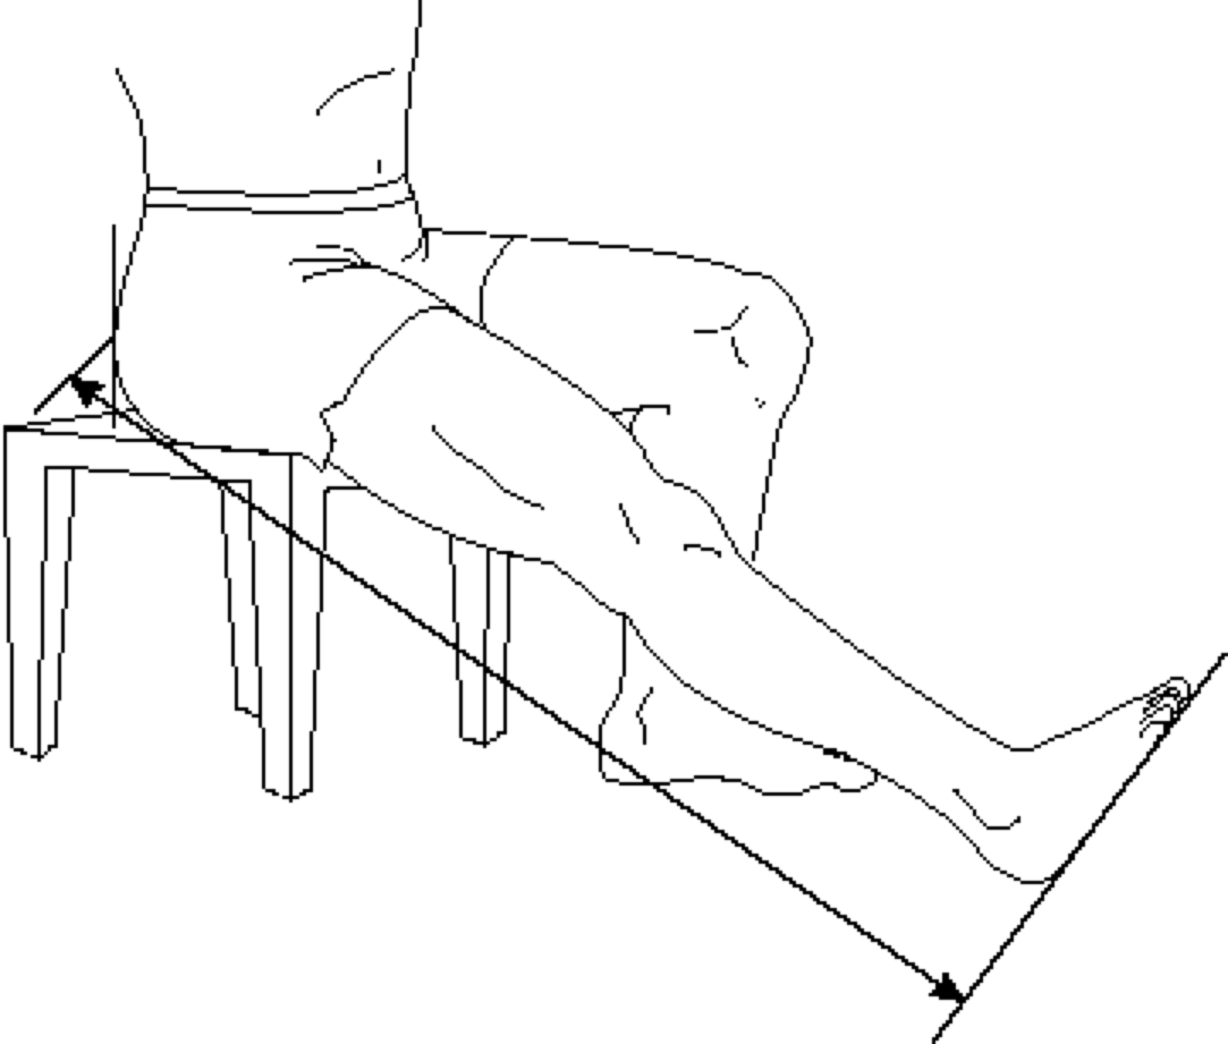
FUNCTIONAL LEG LENGTH

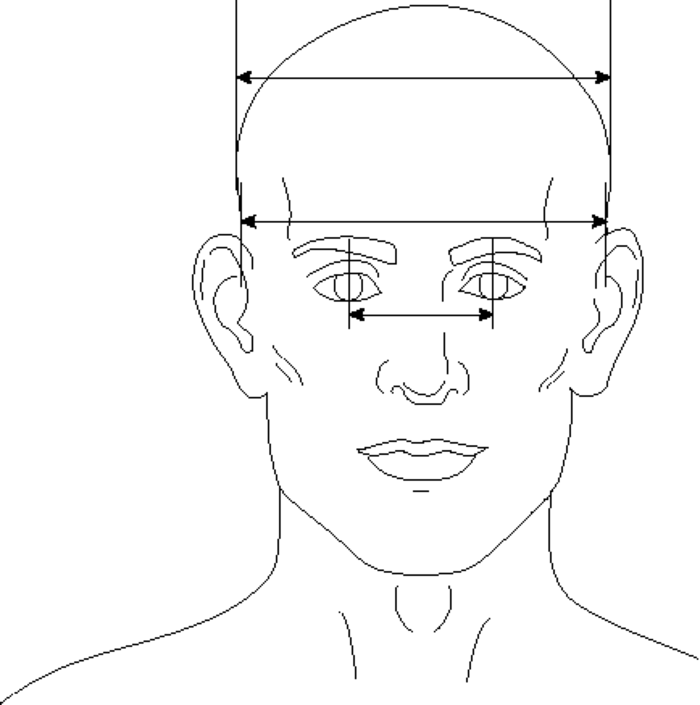
HEAD BREADTH
BIMASTOID BREADTH
INTERPUPILLARY BREADTH

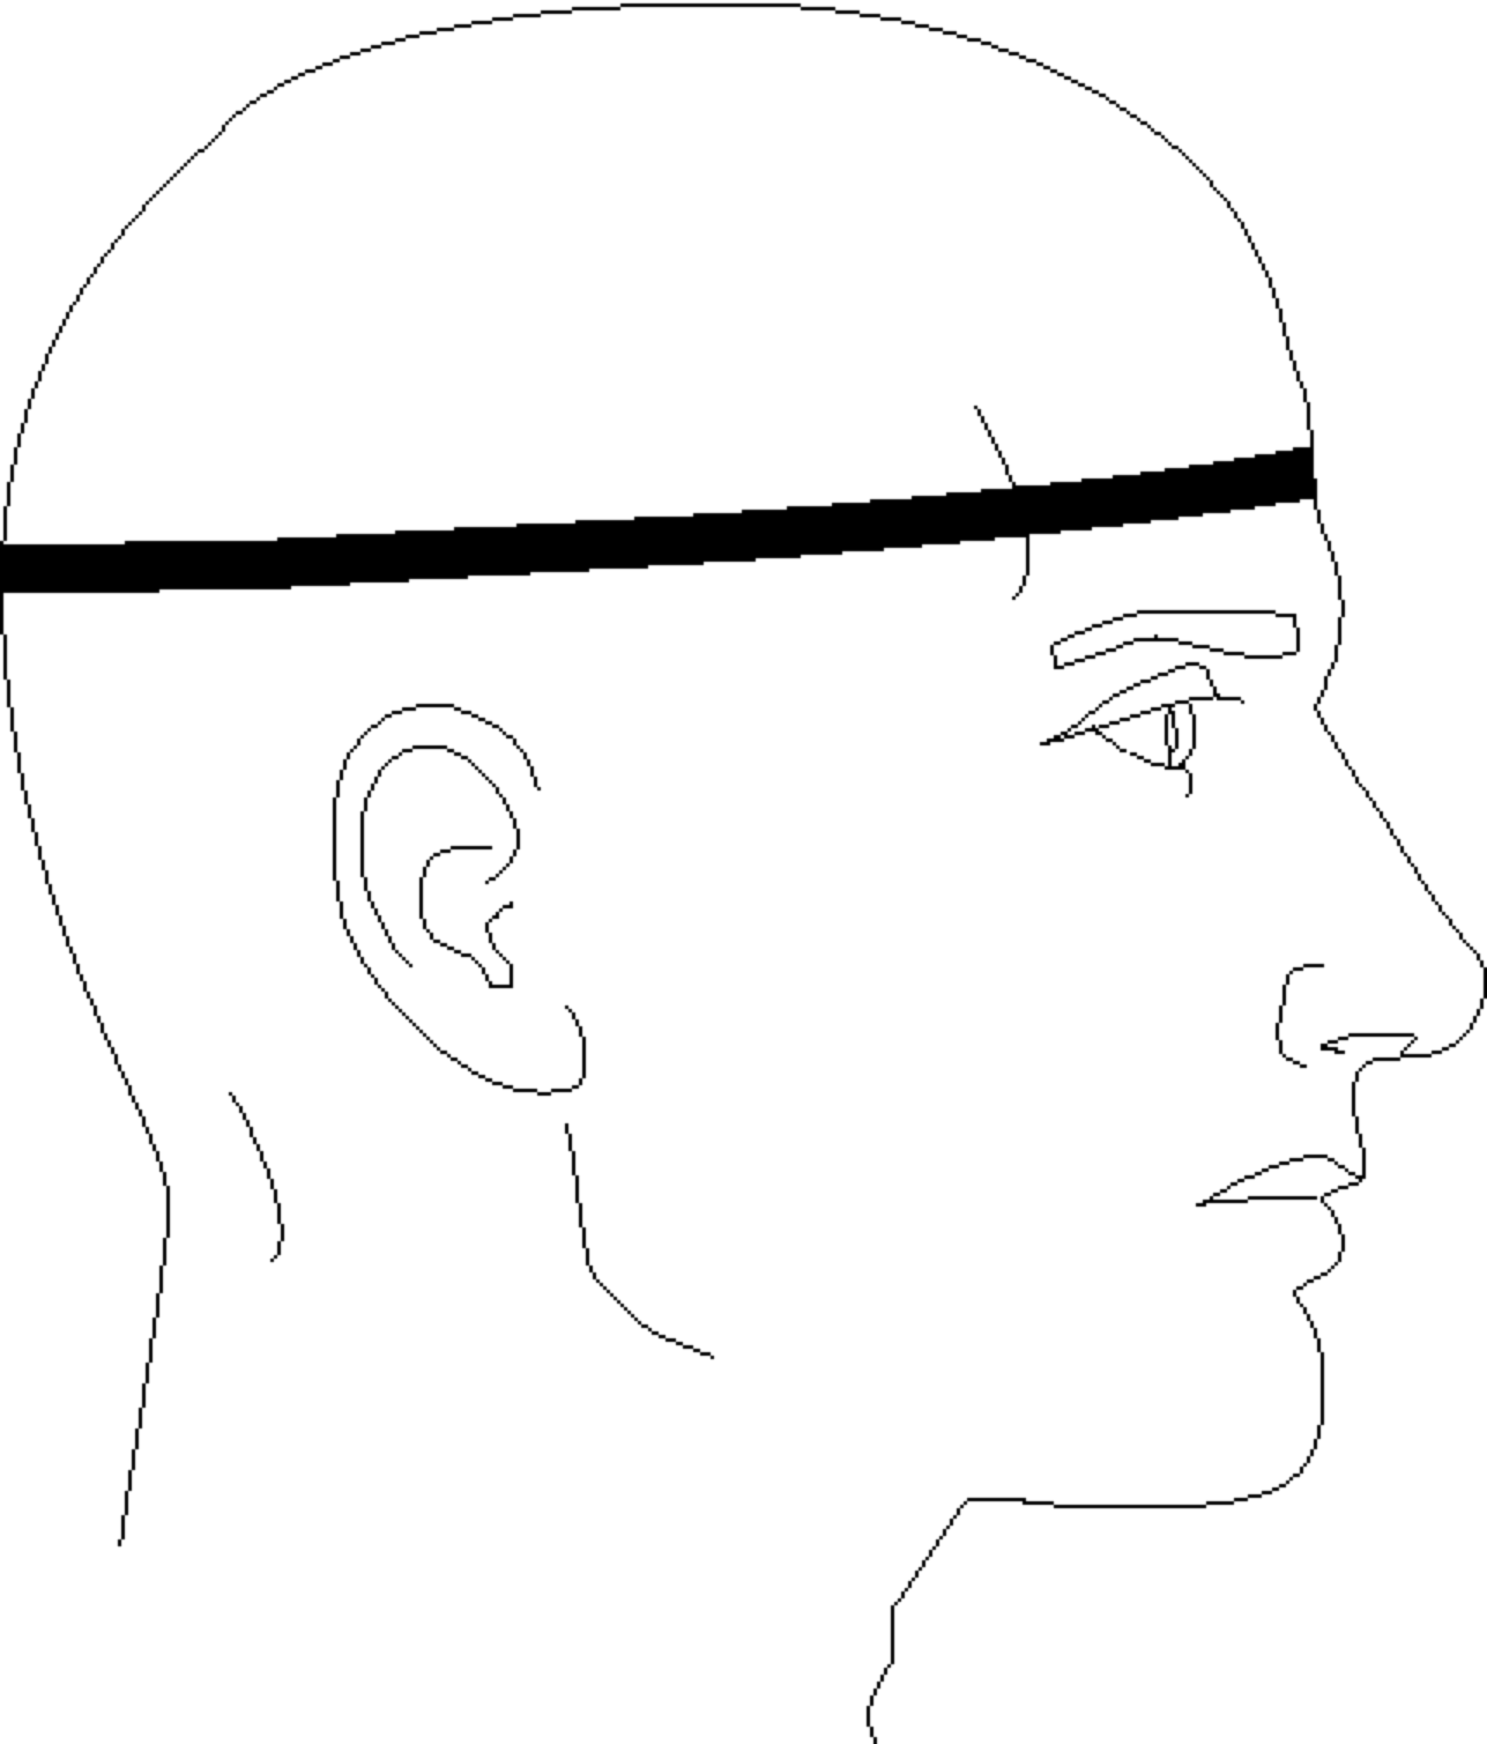
HEAD CIRCUMFERENCE

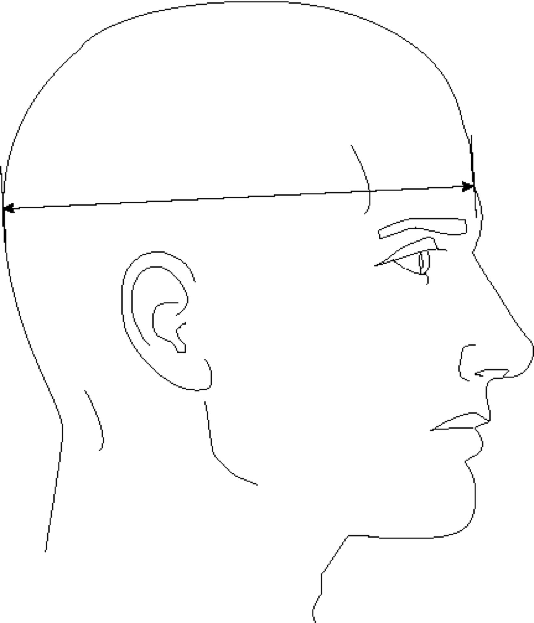
HEAD LENGTH

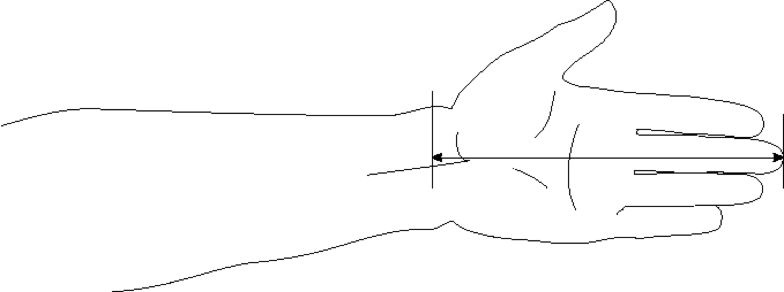
HAND LENGTH
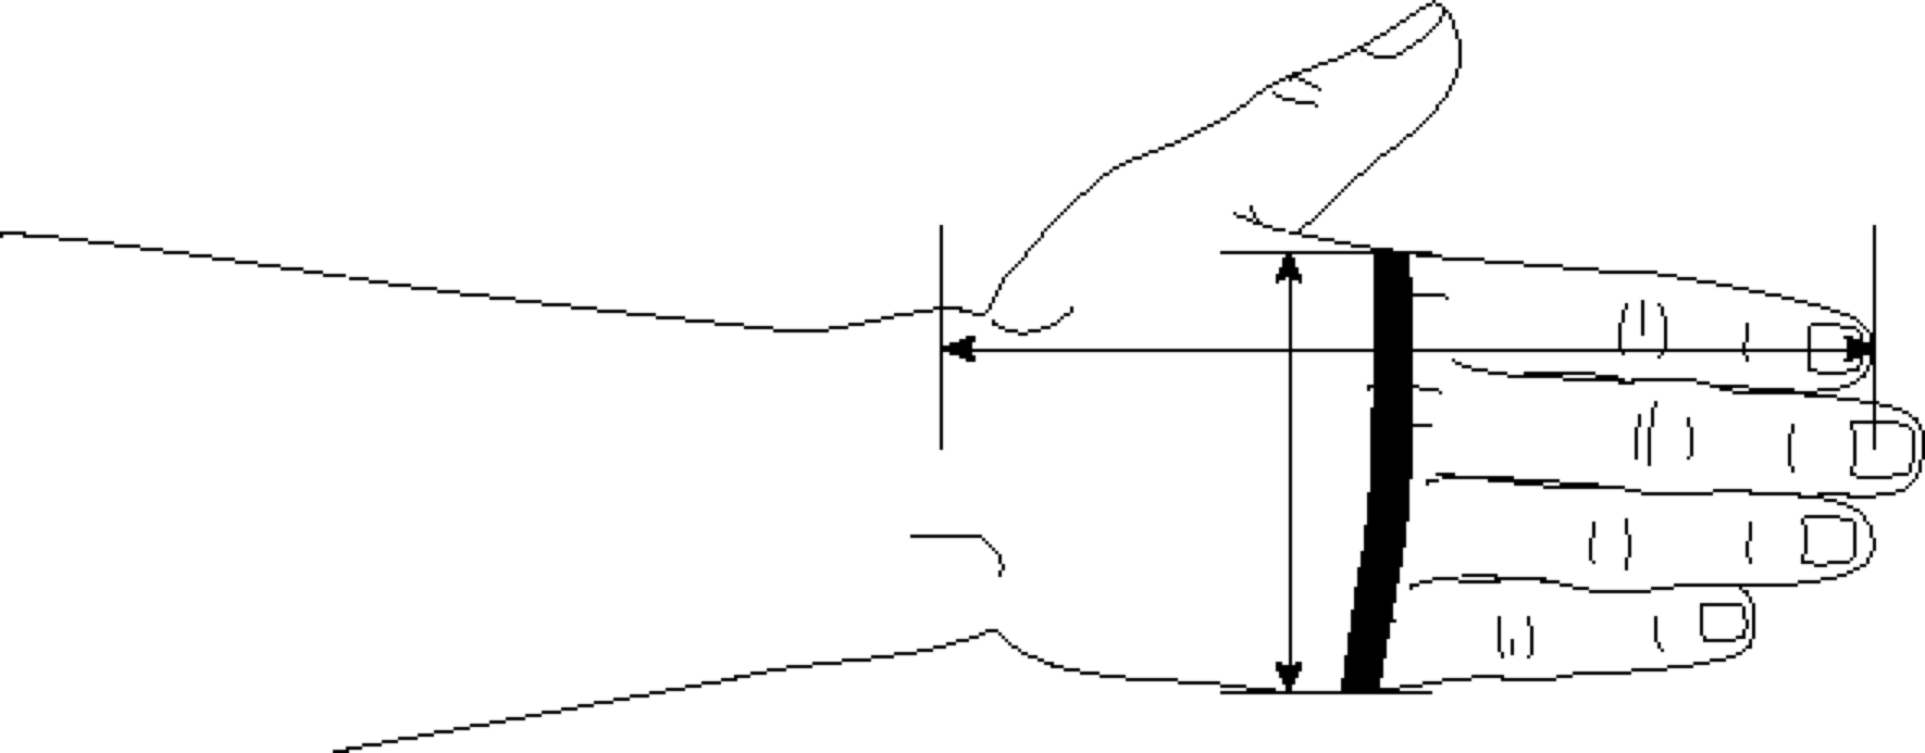
WRIST-INDEX FINGER LENGTH
HAND BREADTH
HAND CIRCUMFERENCE

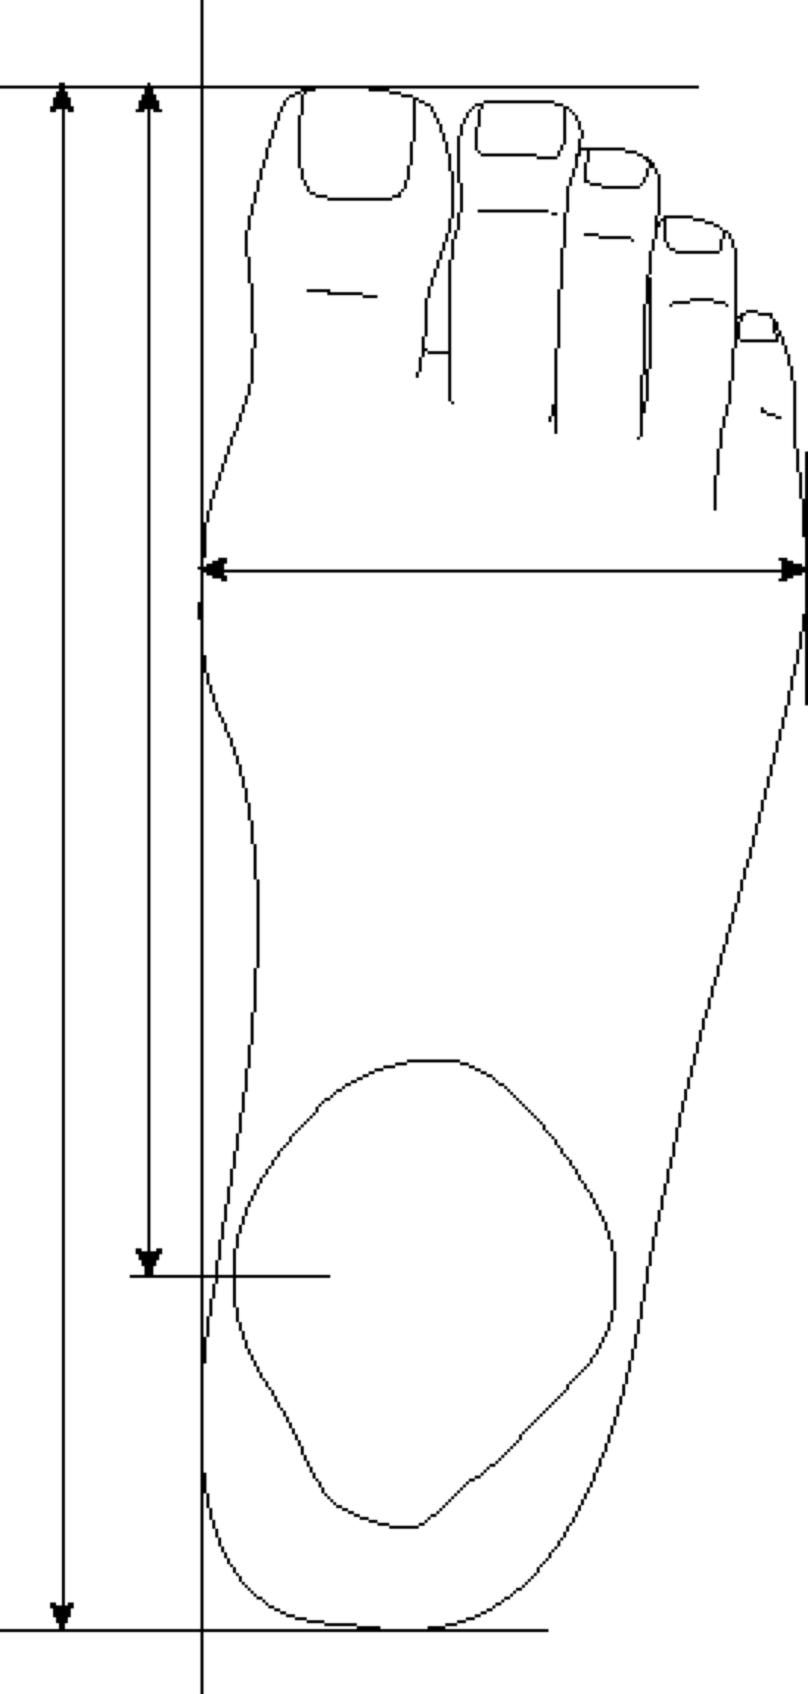

FOOT LENGTH, TOTAL
FOOT LENGTH, ANTERIOR
FOOT BREADTH, HORIZONTAL
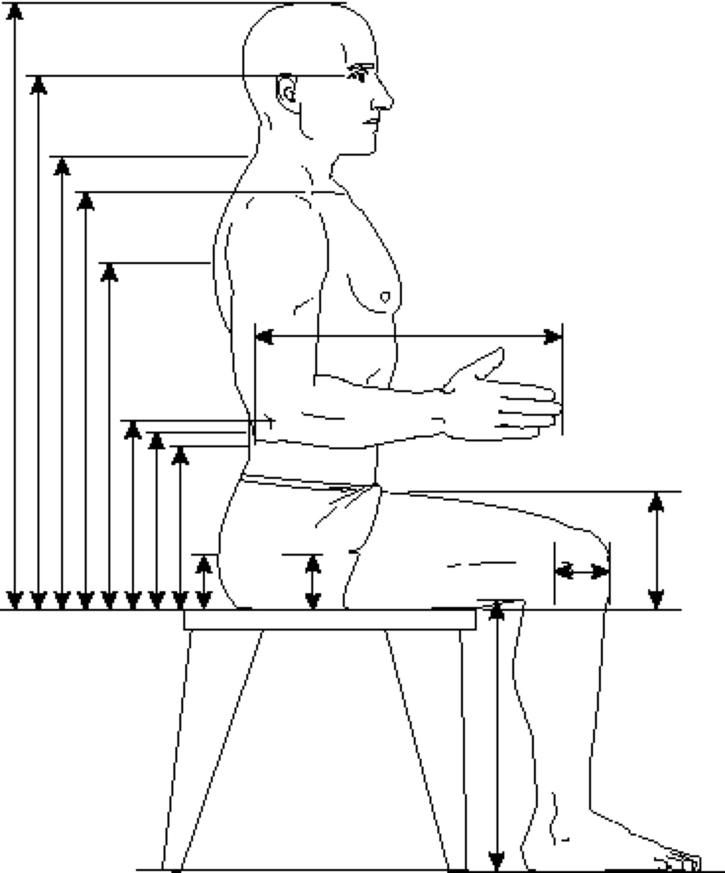

Heights, from Left:  SITTING HEIGHT  EYE HEIGHT, SITTING  CERVICALE HEIGHT  ACROMIAL HEIGHT, SITTING  THORACIC CURVEPPOINT HEIGHT, SITTING  ELBOW HEIGHT, SITTING  WAIST HEIGHT AT MIDABDOMEN, SITTING  LUMBAR CURVEPOINT HEIGHT, SITTING  BUTTOCK POINT HEIGHT, SITTING  TROCHANTER HEIGHT  POPLITEAL HEIGHT  THIGH CLEARANCE | Lengths, from Top:  FOREARM-HAND LENGTH  FEMORAL EPICONDYE-KNEE FRONT DISTANCE, SITTING
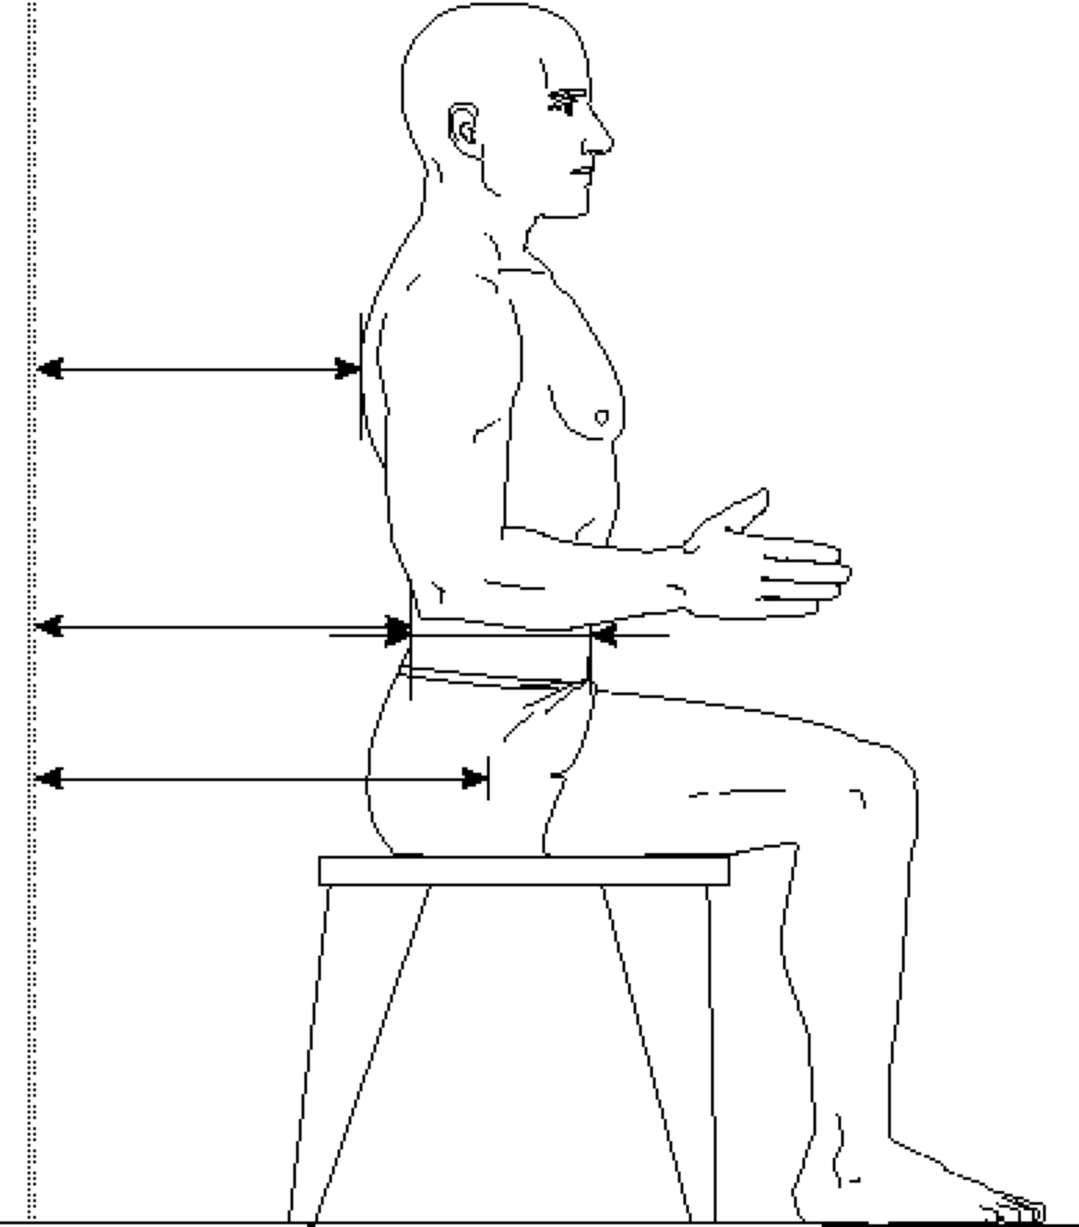

THORACIC CURVEPOINT DEPTH, SITTING
LUMBAR CURVEPOINT DEPTH, SITTING
TROCHANTER-POSTERIOR REFERENCE DISTANCE
ABDOMINAL DEPTH, SITTING
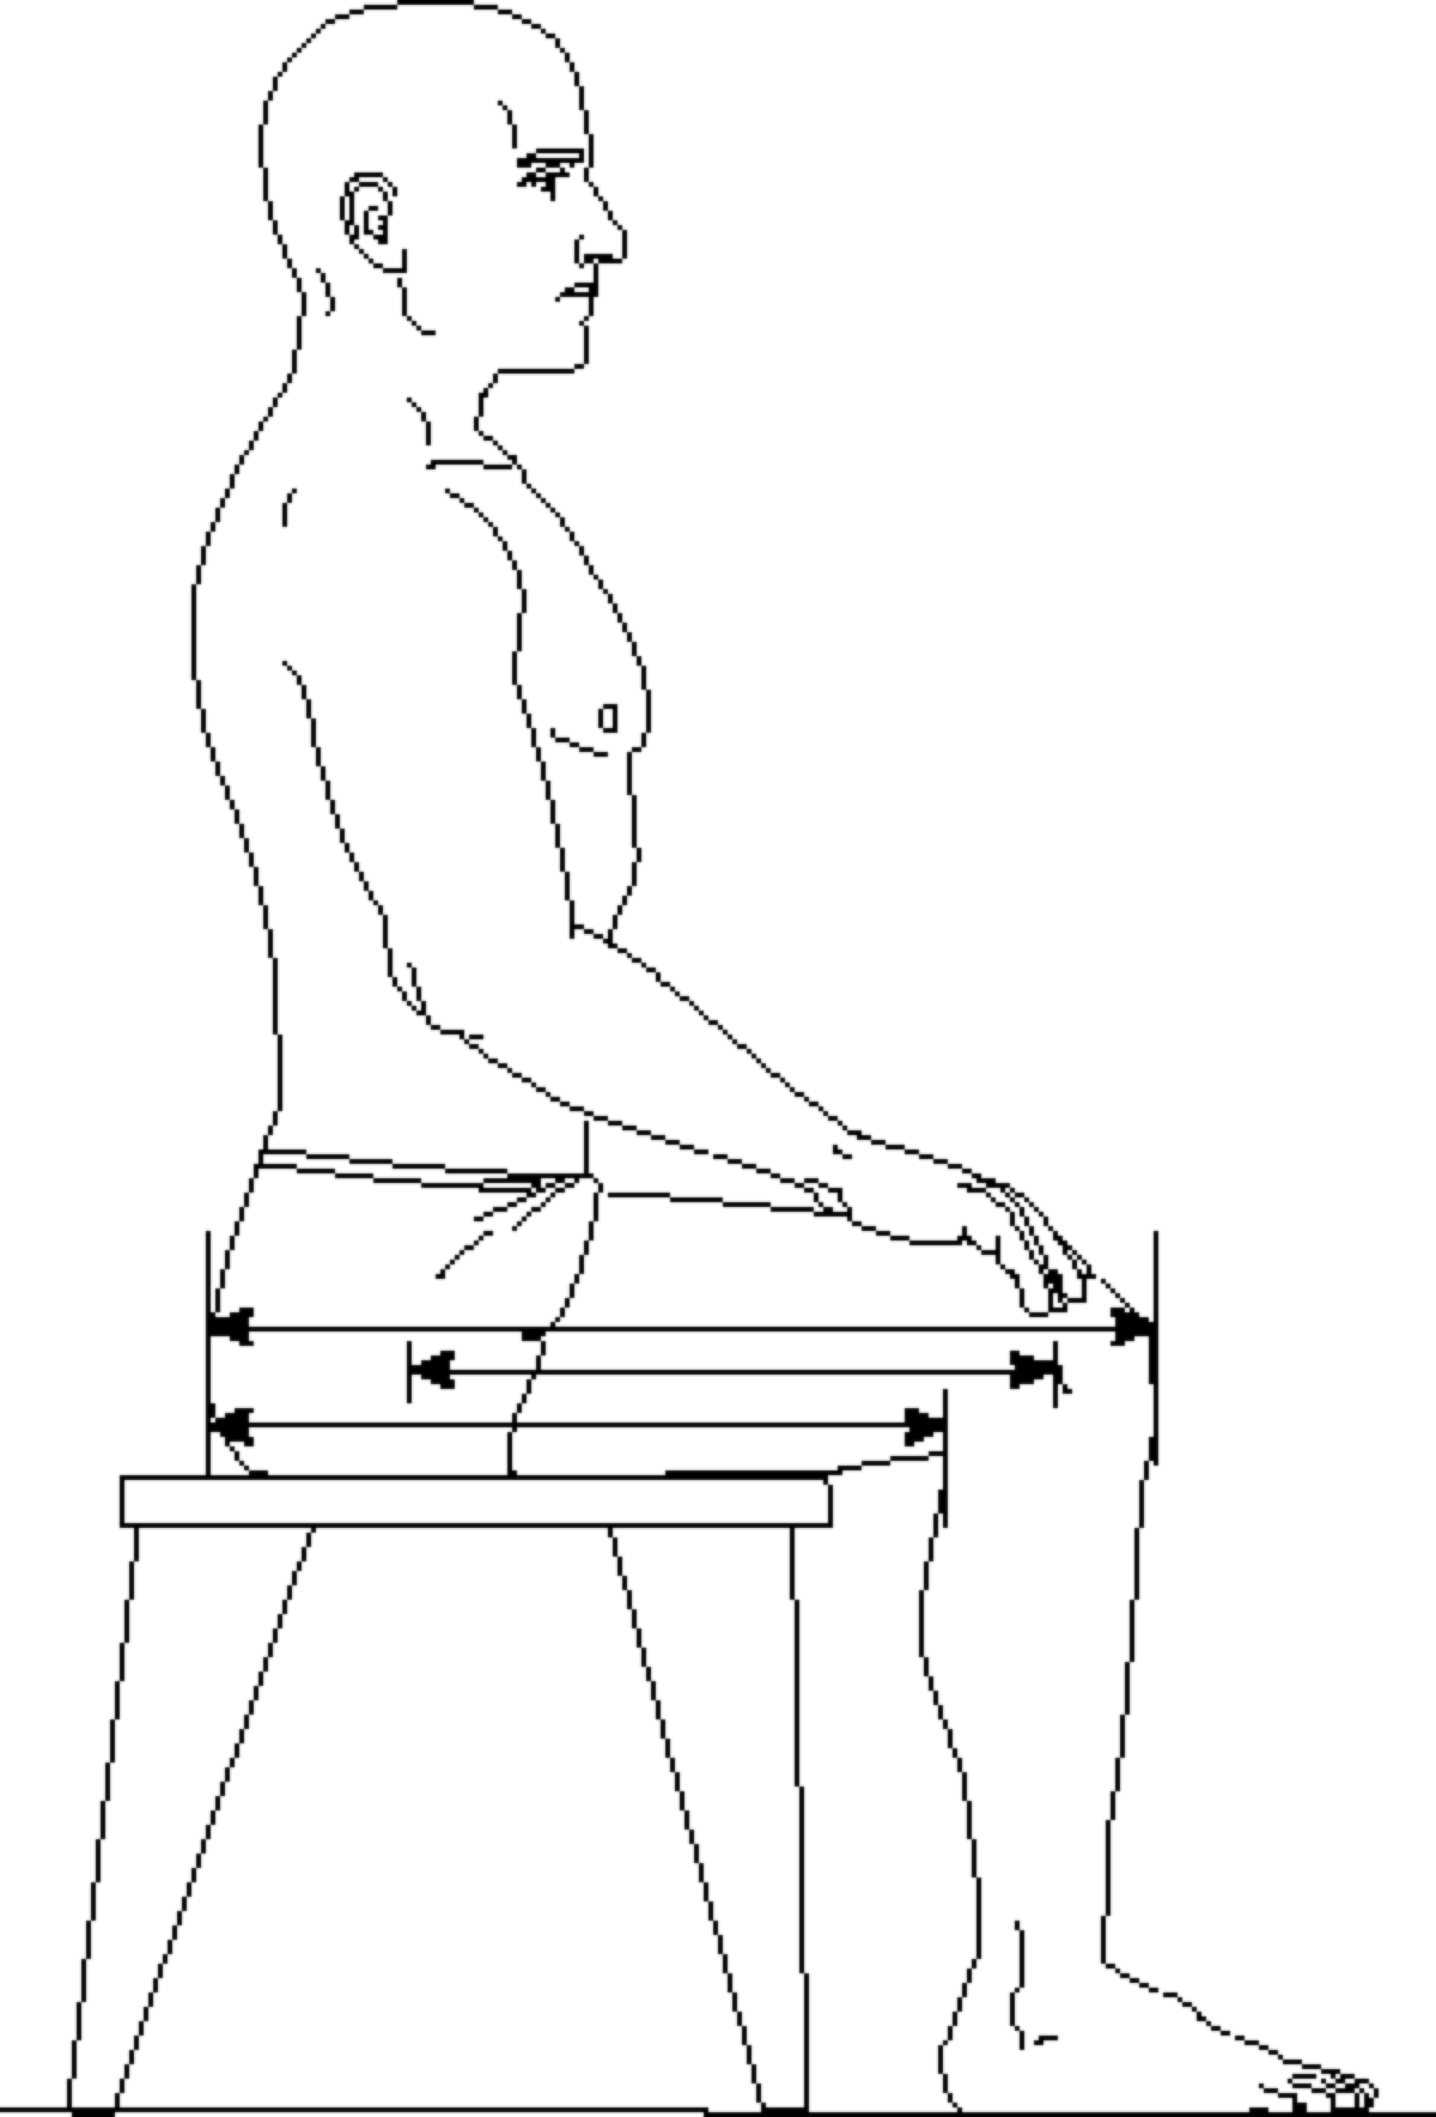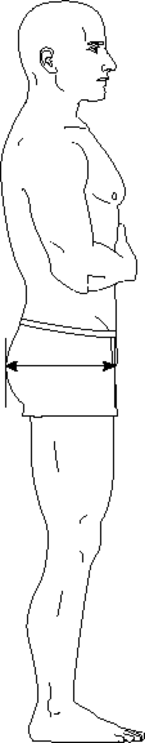

BUTTOCK-KNEE LENGTH BUTTOCK DEPTH
BUTTOCK-POPLITEAL LENGTH
TROCHANTER-LATERAL FEMORAL EPICONDYLE DISTANCE, SITTING
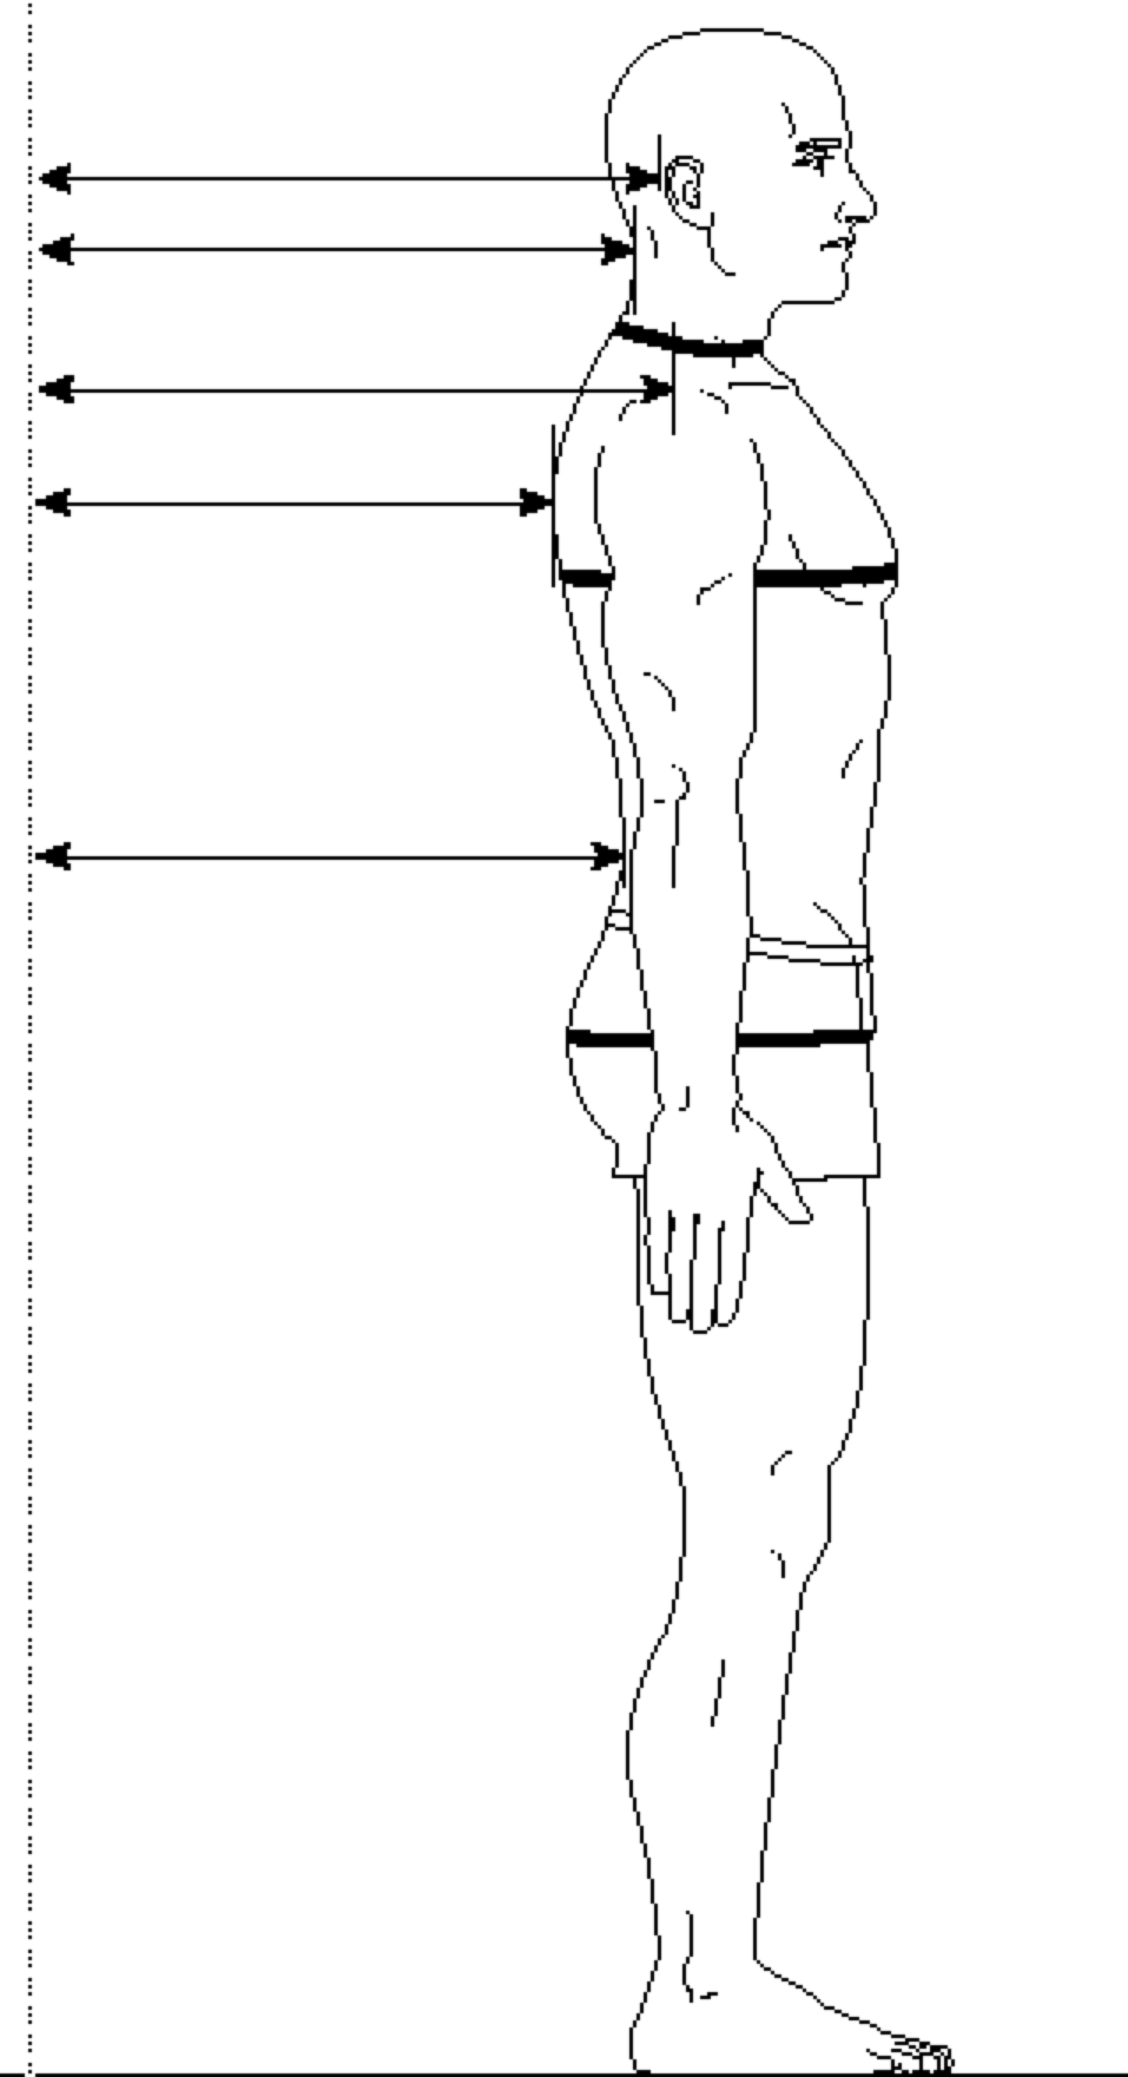

MASTOID-WALL DISTANCE
CERVICAL CURVEPOINT DEPTH
ACROMION-TO-WALL
THORACIC CURVEPOINT DEPTH
LUMBAR CURVEPOINT DEPTH
NECK CIRCUMFERENCE
CHEST CIRCUMFERENCE
BUTTOCK CIRCUMFERENCE

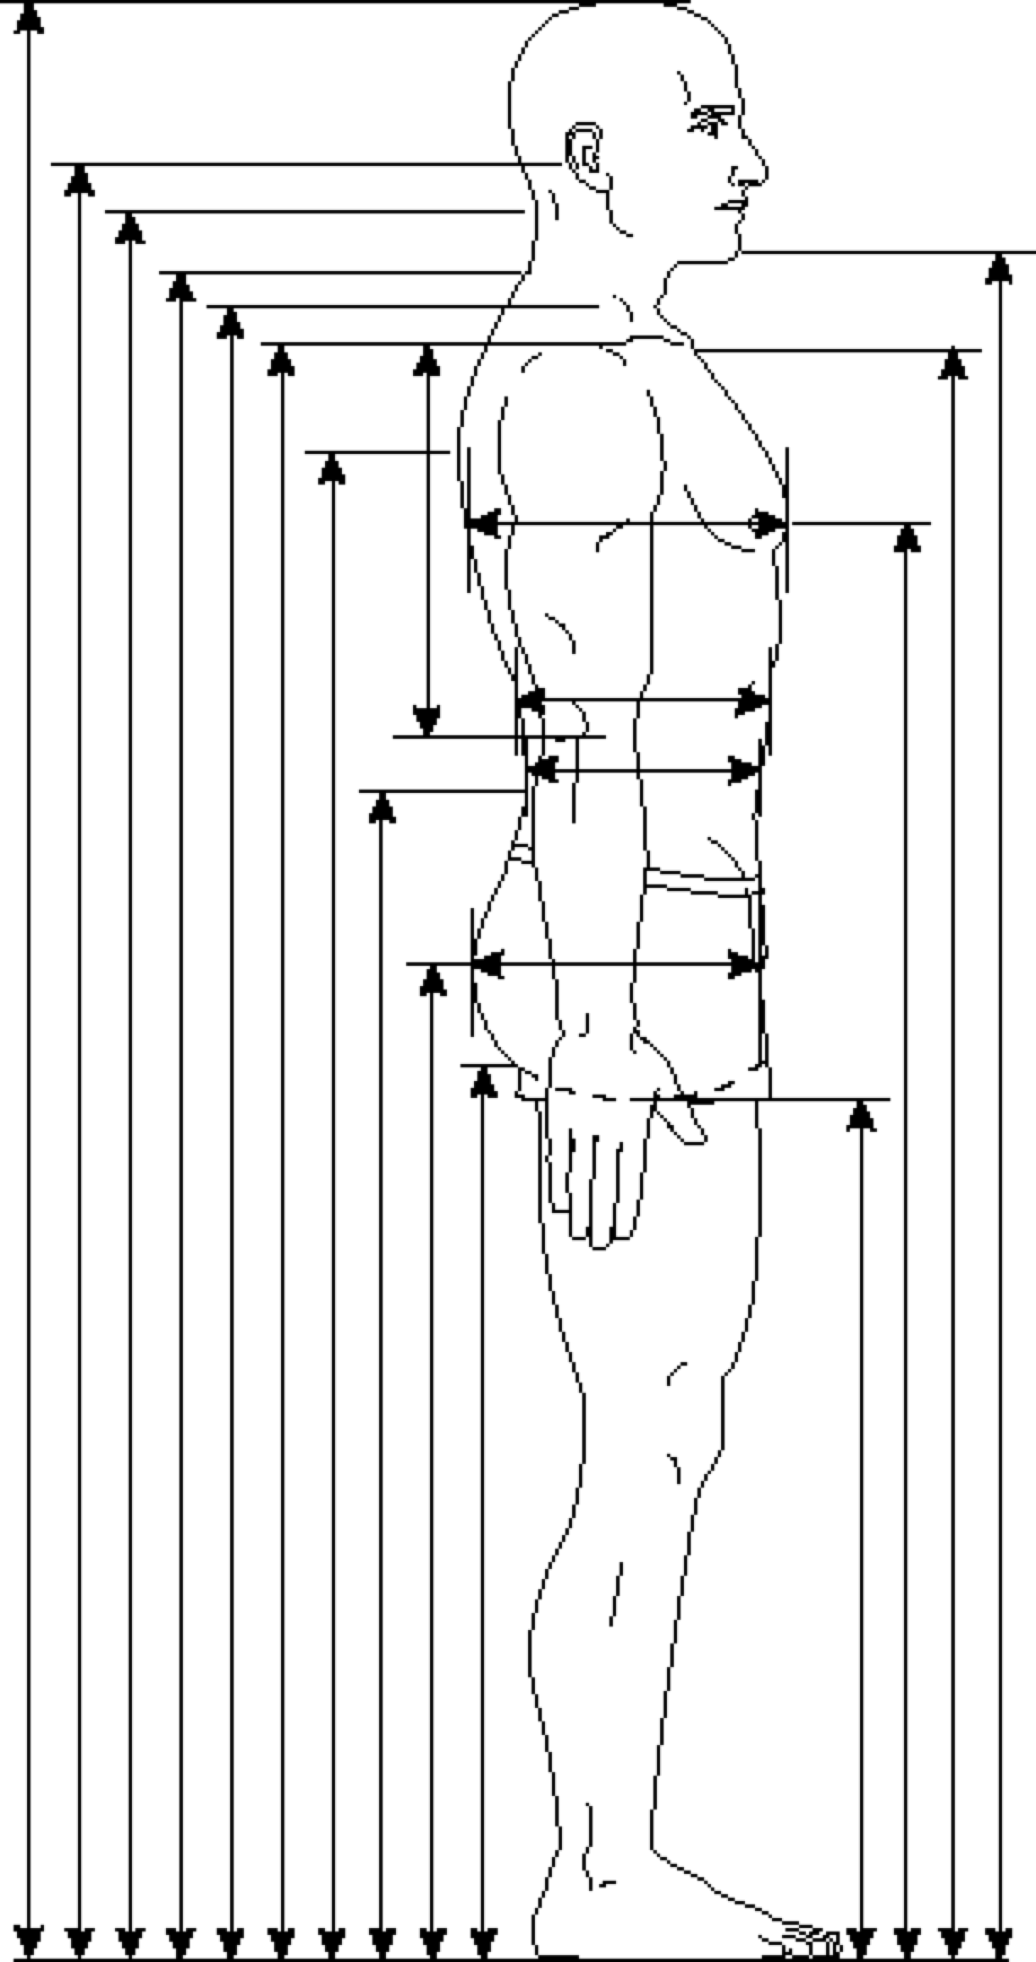

Heights, from Left:  STATURE  MASTOID HEIGHT  CERVICAL CURVEPOINT HEIGHT  CERVICALE HEIGHT  NECK HEIGHT, LATERAL  ACROMIAL HEIGHT  THORACIC CURVEPOINT HEIGHT  LUMBAR CURVEPOINT HEIGHT  BUTTOCK HEIGHT  GLUTEAL FURROW HEIGHT  CROTCH HEIGHT  CHEST HEIGHT  SUPRASTERNALE HEIGHT  CHIN HEIGHT | Depths, from Top:  CHEST DEPTH AT NIPPLE  CHEST DEPTH AT TENTH RIB  WAIST DEPTH AT MIDABDOMEN  BUTTOCK DEPTH

